**DAILY ONLINE ACTIVITIES SUMMARY**

|  |  |  |  |  |  |  |  |  |
| --- | --- | --- | --- | --- | --- | --- | --- | --- |
| **Date:** | **20-06-2020** | | | | | **Name:** | **Preethi** | |
| **Sem & Sec** | **6th - B** | | | | | **USN:** | **4AL17CS065** | |
| **Online Test Summary** | | | | | | | | |
| **Subject** | | **Programming in C++** | | | | | | |
| **Max. Marks** | | **-** | | **Score** | | | **-** | |
| **Certification Course Summary** | | | | | | | | |
| **Course** | - | | | | | | | |
| **Certificate Provider** | | | **-** | | **Duration** | | | **-** |
| **Coding Challenges** | | | | | | | | |
| **Problem Statement:2 C and 1 java program** | | | | | | | | |
| **Status: executed** | | | | | | | | |
| **Uploaded the report in GitHub** | | | | | **Yes** | | | |
| **If yes Repository name** | | | | | <https://github.com/PreethiNayak/Daily-Status/tree/master/20June2020> | | | |
| **Uploaded the report in slack** | | | | | **Yes** | | | |

Online Test Details: (Attach the snapshot and briefly write the report for the same)

Programming in C++

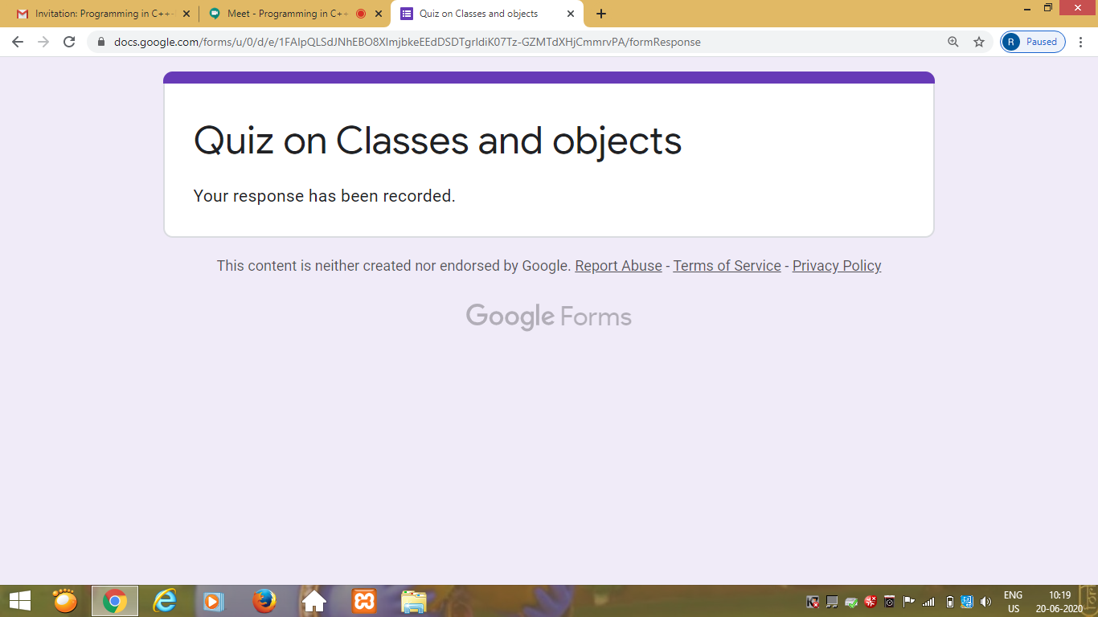

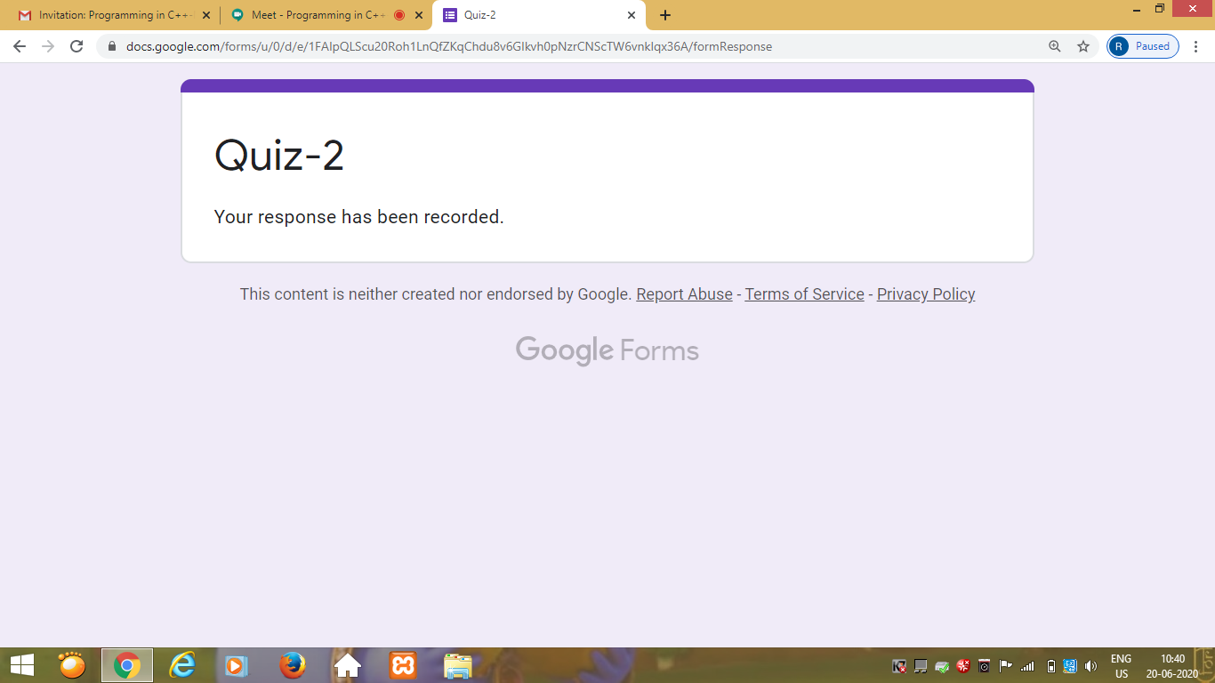

Workshop Details: (Attach the snapshot and briefly write the report for the same)

- - - - - - - - - - - -

Coding Challenges Details: (Attach the snapshot and briefly write the report for the same)

Program 1

This is output of C program to  swap 2 numbers using pointer and function concept, return value from user defined function and print the swapped values in main() function.

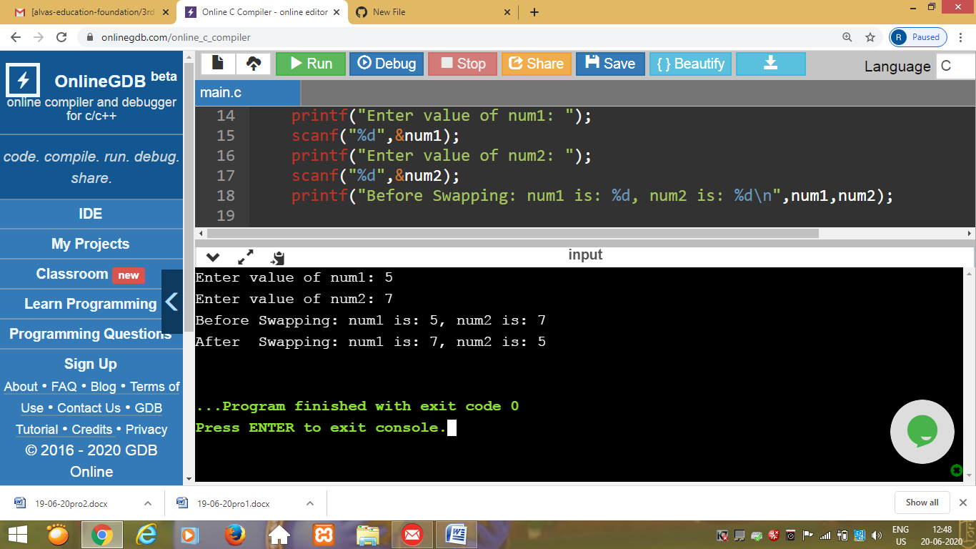

Program 2

This is the output of C program to count the total number of set bits in binary representation of all numbers from 1 to n.

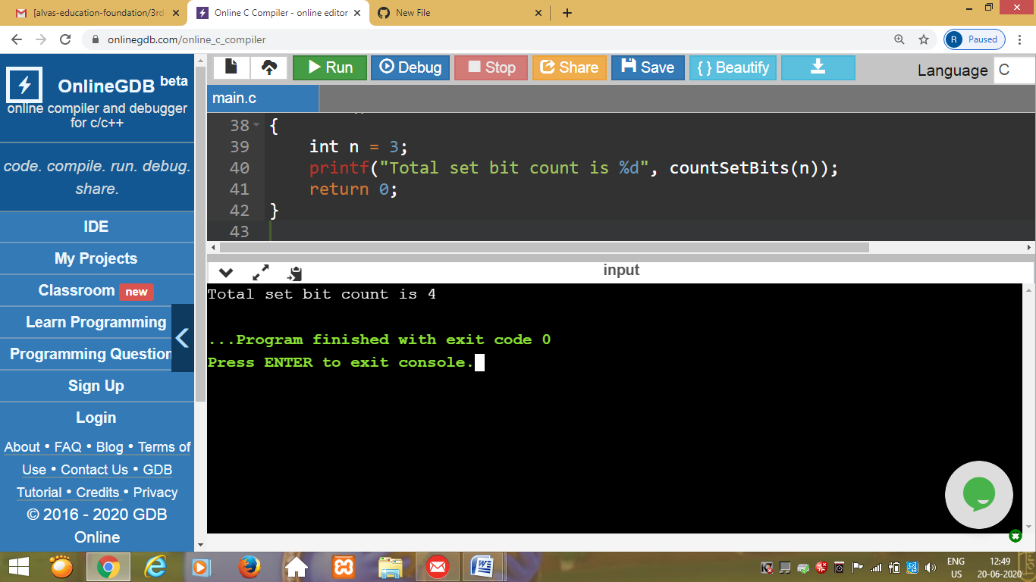

Program 3

This is the output of java program to find the area of Square,Rectangle and Circle using method overloading.

